Joint Force Air Component Command (JFACC) TTP

SUGGESTION TABLE OF CONTENT

Terms / theory

Air Campaign Planning

5 steps of JAOP plan development

Phasing

Objective Determination

Center of Gravity Identification (needed?)

Targeting

JTL (Joint Target List)

JPTL (Joint Prioritized Target List)

Tools

JAOP (Joint Air Operations Plan)

AOD (Air Operations Directive)

ATO (Air Tasking Order)

MAAP (Master Air Attack Plan)

ACP (Airspace Control Plan)

ACO (Airspace Control Order)

SPINS

Command and control /Roles

Event host (CJTF HQ)

VID

VIS

JFACC Role

Tasks

132nd Flow

JAOP Plan process (Start of campaign)

Development of Airspace Control Plan

SPINS

Event

AOD development

ATO development

---- Suggested chapters (written for the 132nd JFACC TTP ----

**Purpose:**

The intention with this document is to provide volunteers in the 132nd JFACC role the necessary background and information about the way JFACC works in a 132nd context. In addition, the document will help campaign designers/mission makers understand how JFACC can be used, and what products are needed from campaign designers/mission makers if they want to use a player staffed by JFACC for the campaign.

**Disclaimer:**

The terms and processes described in this document is drawn from real world references, but are simplified and adjusted to meet the need for conducting a campaign in DCS.

# Chapter 1: Terms

### End State

A end state is the set of required conditions that defines achievement of all objectives. The end state should account for a wide variety of task the force may need to accomplish. The end state describes the set of conditions to meet the conflict termination criteria (war is over).

### Objective:

The objective is why the mission is being conducted and should be determined first. Objectives may be broad or defined by the end state.

An objective is clearly defined, decisive and attainable. Objectives and their supporting effects provide the basis for identifying tasks to be accomplished.

There are four primary considerations for an objective:

* An objective establishes a single result
* An objective (and associated conditions/effects) should link directly or indirectly to higher-level objectives or to the end state. JFACC participants need to know the higher level objective (CJTF objectives, found in the CJTF operations order) and should be able to identify how their objective support the higher level objective
* An objective is specific and unambiguous
* An objective does not imply ways and/or mean - it is not written as a task

Objectives describe what must be achieved to attain the desired end state.

### Effects

An effect is a physical and/or behavioral state of a system that results from an action, a set of actions, or another effect. A desired effect can be thought of as a condition that can support achieving an associated objective and an undesired effect is a condition that can inhibit progress toward an objective.

Effects describes the conditions related to the objectives:

* Desired effects describe conditions needed to achieve objectives
* Undesired effects describe conditions that will impede achievement of objectives.

### Centre of Gravity (COG)

Center of Gravity: That characteristic, capability, or locality from which a military force, nation, or alliance derives its freedom of action, physical strength, or will to fight.

### Critical Capability (CC)

A means that is considered a crucial enable for a center of gravity to function as such, and is essential to the accomplishment of the specified or assumed objective(s).

### Critical Requirement (CR)

An essential condition, resource and means for a critical capability to be fully operational.

### Critical Vulnerability (CV)

An aspect of a critical requirement (CR), which is deficient or vulnerable to direct or indirect attack that will create decisive or significant effects.

### Tasks

Tasks describe friendly actions to create desired effects or preclude undesired effects.

### Mission

Mission describes the organization’s essential task or task(s) and purpose.

### Target set

A ‘target set’ is a group of interrelated target categories within an actor’s system, such as transportation/lines of communication, electric power and adversary media.

### Target category

A ‘target category’ is a group of targets serving the same function, such as bridges, roads, radio broadcasts and newspapers.

### Joint Task Force (JTF)

A force consisting of units from more than one service. For example air, sea and land. All 132nd operations are considered joint operations since they use both air force aviation and naval aviation.

### Combined Joint Task Force (CJTF)

A joint force that includes more than one nation. All 132nd operations are considered combined, since members of the 132nd are from various nations.

### Time Sensitive Target (TST)

Time-sensitive targets (TSTs) are those targets requiring an immediate response because they pose (or will soon pose) a danger to friendly forces or are highly lucrative, fleeting targets of opportunity whose successful engagement is of high priority to achieve campaign objectives.

## Roles

### Joint Force Commander (JFC) (Mission Designer)

Joint Force Commander

JFC is the commander of a JTF or a CJTF. JFC will provide the overall guidance and mission to all components (land, sea, air and special operations).

### Joint Force Air Component Command (JFACC) (Player volunteers)

Joint Force Air Component Commander (JFACC) is the headquarter of the Joint Air Forces in the operation (Both Navy and Air Force, so for us in the 132nd, all air forces)

JFACC plans and executes air campaigns. JFACC have a role both in campaign planning for a campaign, but also for the planning for each ATO day (each event)

The JFACC role is about giving the direction and guidance for air operations. JFACC will publish its guidance before each event in the Air Operations Directive (AOD), and this direction and guidance will be used by everyone involved, especially AWACS controllers and mission commanders/flight leads for planning packages or flights.

If needed JFACC may also request support from other component commands (Land, Sea and Special Operations).

### Virtual Intelligence Directorate (VID) (Mission Designer)

VID provides intelligence injects into the campaign. This can be considered a broader intelligence agency than VIS. VID is the way the mission designer can inject relevant or irrelevant information into the campaign, that can be picked up by VIS and JFACC and used for the execution of subsequent events based on the new information.

### Virtual Intelligence Service (VIS) (Player volunteers)

The VIS role is about providing intelligence for the rest of the organization. The individuals functioning as VIS will try to make sense of the battlefield based on the reports from pilots after events, in addition to intelligence from VID.

VIS has a dual purpose:

1. Support the event planning on a higher level (support to JFACC)
2. Support the event planning on a tactical execution level (support to pilots)

VIS may have intelligence gaps, and can request submit a IR (Information Requirement) to JFACC. JFACC may task specific flight with providing the information asked about in the information requirement.

### Land Component Command (LCC) (Mission Designer)

This is the land component of the Joint Force, and controls the fight taking place on the ground. The land forces are slow to maneuver, but are often the decisive factor. MCC and JFACC will often have a supporting role to help LCC reach their objectives.

### Maritime Component Command (MCC) (Mission Designer)

This is the maritime component of the Joint Force, consisting of surface ships, submarines. Naval aviation is for the 132nd purposes controlled by JFACC. Surface ships operating together may form a Surface Action Group (SAG) with mutual support. MCC may have several SAG`s. Maritime units are fewer in number than land units, and can easily be task organized in various SAG formations based on the need for the specific mission.

### Special Operations Component Command (SOCC) (Mission Designer)

This is the special operations component of the Joint Task Force. Special operations can be used for sensitive missions, or demanding missions that LCC is not suited for. Typical insertions deep behind the enemy line to provide intelligence, or to support attacks by JTACs.

## Products

### Operation Order

The operation order is the overall order from the Joint Force Commander (JFC). It will contain an overall situation, an overview of friendly and enemy forces. It will also contain the mission and the commander’s intent with the operation. Furthermore the operation order contains a broad concept of operation and objectives to be met. The operation order will also list specific tasks to the component commands (Land, Air, Sea, Special operations)

### Joint Force Commander Direction & Guidance (JFC D&G)

When necessary (before an event or a new phase), JFC may see it necessary to provide additional direction and guidance for the overall campaign. This will be published in the JFC D&G document.

### Joint Air Operations Plan (JAOP)

The JAOP is JFACC`s overall plan on how to conduct the campaign. The JAOP will have the mission for JFACC together with the commander’s intent and the objectives for JFACC. It will contain on the concept of operation through information of what is planned to be conducted during the various phases in the operations. The phases may be given in the Operations Order, but JFACC can add new phases or break down the phases in various sub phases. The JAOP will also include a timeline over the various phases and sub phases. The JAOP is created prior to the first event and will be the guiding document for further events.

### Air Directions Directive (AOD)

### Air Tasking Order (ATO)

### Airspace Control Order (ACO)

Per event

### Airspace Control Plan (ACP)

Overall plan with all airspace information

### Special Instructions (SPINS)

This is a document used for mission designer and JFACC to place information for the campaign. To be read by all pilots and controllers participating on an event.

### Joint Target List (JTL)

### Joint Prioritized Target List (JPTL)

# Chapter 2: Theory

## Air Campaign planning

5 steps JAOP plan development

### Step 1: Operational Environment Research.

This step is focused on gaining information about friendly and adversary capabilities and intentions, doctrine, and the environment in which the operations will take place. The goal of this phase is to gain an understanding of the area of operations, the adversary, and friendly forces available to accomplish the JFC’s objectives. Key factors such as threats and airbase availability will affect the strategy development process. A larger enemy air threat requires more time and assets dedicated to the achievement of aerospace superiority, to the initial detriment of

other missions. Airfields further from the AOR may be used by long-range or tanker-assisted assets, but the increased mission duration will reduce the number of targets that can be attacked in a given period. Such airfields may be at lower risk to enemy air and missile attack,

however, providing a tradeoff between efficiency and survivability.

### Step 2: Centers of Gravity Identification.

Within the framework of the step process, Step 1, Operational Environment Research, almost naturally flows into a more detailed, in-depth study of **your adversary** known as **center of gravity (COG) analysis**. This analysis should provide you with as clear a picture as possible of how an adversary functions; of his strengths, and of his possible vulnerabilities to dislocation and exploitation by air power.

Clausewitz was the first to apply the term “*center of gravity”* to warfare. He described a center of gravity as, “**the hub of all power and movement, on which everything depends**.” Clausewitz clarifies this description by stating that “the ultimate substance of enemy strength must be [traced back to the fewest possible sources, and ideally to one alone.” Other writers have used terms such as “vital centers,” “key nodes,” “decisive points,” or “critical vulnerabilities” to approach the same concept. They were partly right. The “hub of power and movement” itself is the “center of gravity.” Take the “hub” away and the enemy system ceases to function or the enemy ceases to act against you. That “hub” has certain characteristics, *among them critical vulnerabilities*. These vulnerabilities will naturally flow into target sets. From these target sets, individual targets can be identified and attacked as required to support the campaign’s objectives. Given proper analysis, successfully attacking those targets will decisively affect the center of gravity.

**COG Analysis.** COG analysis is important to targeting efforts because it identifies the adversary’s strengths and weaknesses, and how the adversary organizes, fights, and makes decisions. This analysis helps identify where those sources of power are vulnerable, where critical nodes within them are, and how they can be exploited.

Analysis begins with the COG as a source of power. The analysis identifies the inherent abilities that allows the COG to act as such (critical capabilities); identifies the essential conditions, resources, or means (critical requirements) that allow the COG to operate; and then determines where those critical requirements are vulnerable (critical vulnerabilities [CVs]). Collectively, these are called critical factors. While it can sometimes be difficult to pick CVs from critical requirements or translate the former into explicit target sets, analysis performed during target development can help “operationalize” this technique’s insights.

COGs are nouns—tangible or intangible sources of power. CC can be thought of as verbs—things a COG does. CRs are nouns—those things a critical capability needs to function as such. CVs are those critical requirements that are vulnerable.

Example:

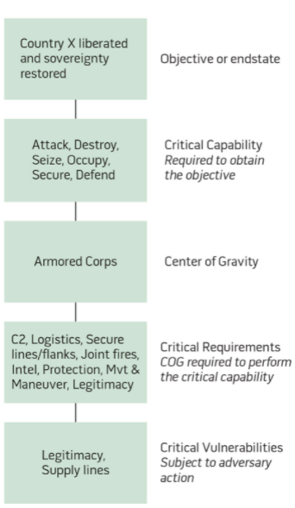

In order to achieve the JFC’s objectives, the campaign planner (JFACC) must ask the following:

* which COGs do I try to affect?
* how do I affect them?
* to what extent do I affect them?
* When do I affect them?”

The answers come from a comprehensive center of gravity analysis.

**Types of attack.** As JFACC planners, your COG analysis should yield an understanding of which enemy systems are critical to his resistance, which of these are vulnerable to attack, and which are feasible to attack. Attack,of course, does not always imply physical destruction of a COG or its components. Centers of gravity may be attacked **directly** or **indirectly** (or in a combination of the two).

* ***Direct*** *attack*, as its name implies, involves *attacking the COG itself or engaging it in decisive combat*.
* ***Indirect*** *attack involves causing the same or similar effect by attacking a COG’s supporting or related elements*. Another indirect technique involves attacking targets that may produce a new, more accessible COG. For example, if an individual national leader is identified as a COG, direct attack on his/her person might accomplish the objective of ending the war. If, however, such an attack is not allowed by national policy or the law of armed conflict, then you might have the *same effect* by attacking the leader’s ability to communicate with the components of his system.

**Parallel Attack.** Centers of gravity should be attacked as systems. Airpower is unique in its ability to affect every facet of a COG. If POL is the COG, it can be attacked from the point where it comes out of the ground all the way to the point where it goes into a combat vehicle (or into an enemy leader’s electrical generator). There may also be key elements in a COG’s target set that look like they could bring down the COG if attacked independently, but which should be attacked in parallel with other elements (resources permitting) in order to stress the entire target system. This has the added benefit of reducing the impact of errors in your analysis caused by fog and friction, and further reduces the enemy's reconstitution potential. Hedge your bets by attacking as much of the system as you can afford—until you achieve your objective.

**COGs and targets.** Also note that *COG analysis does not lead to an exhaustive list of targets*. There are some targets, often unrelated to enemy COGs and their critical vulnerabilities, that must be struck, either to enable attacks elsewhere within the enemy system or to defend your own centers of gravity. An example of an enabling attack might be suppressing enemy air defenses (in a case where those defenses were not themselves identified as a COG) in order to strike a COG-associated target set deep in the enemy’s country.

**What really matters:**

The following are COG-related ideas that are critical for planners (from planning team members to commanders) to know and believe:

* A COG is based on and linked to an objective; indeed, it is what accomplishes an objective.
* COG identification and analysis provide the foundation for COA development.
* COG is a planning concept; objectives or capabilities may change in execution, necessitating re-analysis of COGs.
* A great part of the value of COG analysis to planners are the discussion and debate that arise from conducting the analysis.
* Identification and analysis of COGs must be done as discretely as possible for focus and clarity in COA development.
* Multiple varying objectives may necessitate multiple COGs.

In summary, centers of gravity are those things from which an actor in a conflict derives his power or freedom of action. We analyze them in order to determine critical vulnerabilities within them that will yield the most effective use of air power in achieving a campaign’s objectives.

Visualization of COG, Critical capabilities, critical requirements and critical vulnerabilities:

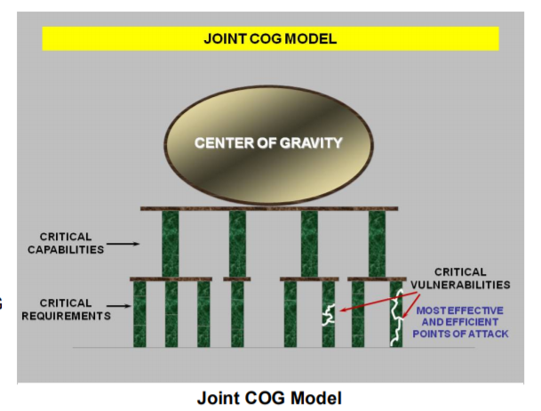

Figur 1 :https://www.doctrine.af.mil/Portals/61/documents/AFDP_3-0/3-0-D30-Appendix-1-COG-Analysis.pdf

Example COG analysis:



Figur 2 : https://ndupress.ndu.edu/media/news/article/969689/lets-fix-or-kill-the-center-of-gravity-concept/

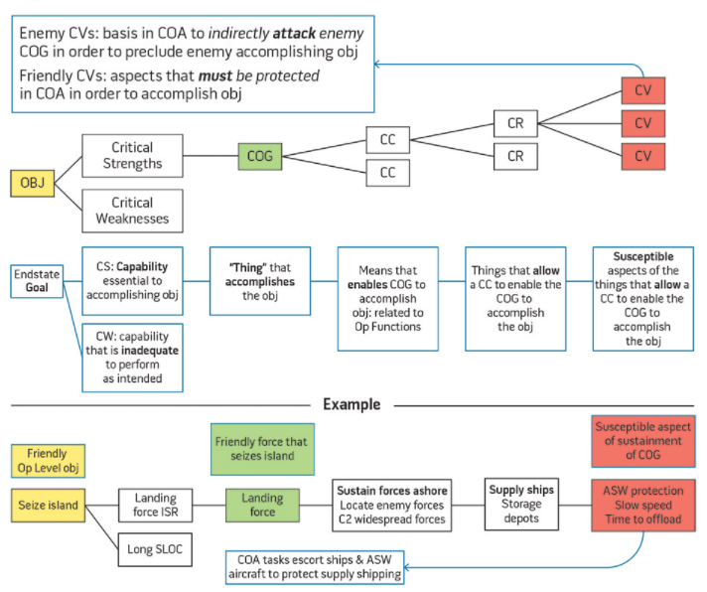

Figur 3 https://ndupress.ndu.edu/JFQ/Joint-Force-Quarterly-82/Article/793278/the-primacy-of-cog-planning-getting-back-to-basics/

### Step 3: Objective Determination.

The output of this step is clearly defined and quantifiable JFACC objectives that will contribute to the accomplishment of the JFC’s overall objectives.

Air objectives should logically flow from the JFC`s objectives. **If** **you cannot tie an air objective to** **JFC objectives,** **do not commit resources to it** unless you believe an objective has been overlooked. Some intermediate air objectives (those necessary to achieve the end goals of a primary objective) may not appear to be directly related to the JFC objectives. They are, however, appropriate air objectives and should be included in the air plan. For example, some level of air and space control gained through counterair operations will probably be a necessary prerequisite for a primary objective dealing with paralyzing the enemy.

The development of objectives and guidance is the first and the most critical step in the targeting cycle. Objectives and guidance identify what is to be achieved and under what conditions and parameters. An objective must be understandable, attainable, measurable, and allow room for a solution.

An objective defines the specific targeting problems to be solved. Measurable, definitive objectives must be given or derived from the guidance provided. A good objective must be understandable, require action, be attainable, allow some room to reach the solution, and provide criteria for use in measuring both progress and effectiveness.

**Creating objectives**

Eight questions should be answered when defining an objective. See Annex 1.

#### What do we want to make the enemy do?

Identify the enemy activity to be affected, changed, or modified. Normally, only a few enemy activities are encountered: offensive and defensive air operations, ground activity, naval activity, logistic activity, and economic activity.

#### Against whom?

The specific goal (rather than a generalized or national goal) must be identified. For example, do we wish to modify the behavior of political leader, military forces, the civilian population, or a combination of these three?

#### Where do we want to affect enemy activity?

The specific location where activity should be modified is a significant part of the objective. By stating “where," the workload of the target analyst can be greatly simplified. For example, if only local air superiority is required, there is no need to prepare an analysis to support attaining air superiority for the entire country.

#### When and for how long do we want to reach the objective?

Four principle timing factors must be considered in formulating an objective:

**Timing of the Attack**. Determining the most opportune time to attack to gain maximum

benefit while minimizing cost is a key to targeting. The inherent speed and flexibility of airpower

can best be exploited through synchronized, parallel attacks on the enemy’s centers of

gravity. When properly timed, parallel attacks can overwhelm the enemy’s command and control

and defensive systems, creating strategic paralysis. This principle was brilliantly applied on the

opening night of Desert Storm, as the Iraqi air defense network was struck with precisely timed

parallel attacks and quickly rendered ineffective. The Iraqi defenses were first blinded by nearly

simultaneous attacks on early warning radars, then paralyzed by successive attacks on key command and control nodes.

**Timing of Strike Impact on Enemy Operations**. The timing of attacks should be

based on enemy time-table or “time critical” parameters. “Time critical” parameters are time-sensitive tasks or activities that must be effectively and efficiently performed by the enemy for his plans to succeed. To target the enemy effectively, his goals and tasks (particularly those which are time sensitive) must be identified. “Time critical” periods must be determined. This involves maintaining an intelligence posture capable of detecting, reporting, and assessing the conduct of enemy tasks prior to and during friendly operations. During offensive operations the general attack is followed by resupply or the introduction of follow-on forces. The interdiction of these can severely hamper an attack.

The time from the attack until its impact is felt is very important. For example, striking or attacking enemy supplies stored near the battle lines will have a more immediate effect on the battle than striking or attacking supplies stored in rear area warehouses or striking enemy factories. If the effects of friendly strikes or attacks are to be felt immediately, different targets may have to be selected than if immediate impact on the enemy is not required. Attempts to have an immediate impact may delay the achievement of longer range goals. Such trade-offs must be considered in establishing the timing criteria in objectives. Factors such as enemy supply cushion and reserves are also important considerations in selecting targets for attack for immediate or long term impact.

**Synchronization of Attacks**. Individual attacks should be timed for maximum synergy in achieving the overall objective. The inherent speed and flexibility of airpower can be exploited through synchronized, parallel attacks on the enemy’s centers of gravity. When properly timed, parallel attacks can overwhelm the enemy’s command and control and defensive systems, creating strategic paralysis. This principle was brilliantly applied on the opening night of Desert Storm, as key air defense nodes were struck in precisely timed parallel attacks and quickly rendered ineffective.

**Recuperation and Reconstruction Time**. Recuperation and reconstitution times are also critical in targeting. The period during which the target is to be neutralized will influence the type and amount of force to be used. For example, a few aircraft could attack local defenses and achieve local air superiority for a limited time, but it would take many more aircraft to gain air superiority or supremacy over a long period.

#### How do we want to reach the objective?

A variety of means toward an end generally suggest themselves. Bombing strikes or attacks, display of intent or demonstration of force, airborne or missile attack, psychological operations, etc., are some choices available. There is also a wide choice of weapon systems available. In most cases, they will be combined. The systems available, or the situation, may dictate the use of a specific vehicle to achieve a desired targeting objective. For example, a B-2 may be the only delivery vehicle able to reach a particular location in time to act. No decision should be arbitrary. Decisions on objectives should recognize external factors which may compel analysts to limit their investigation.

#### How much (to what degree) do we want to affect enemy activity?

State the criteria against which progress and success will be measured. Criteria must use quantifiable terms and be realistic. Criteria should assist in understanding objectives by providing a performance measure. For example, an objective such as “gain air superiority” is not specific enough; it has no measurable criteria. It might be stated better as “gain air superiority by degrading enemy operational capability to inflict damage on friendly forces by reducing the enemy's strike sorties to less than 10 per day,” or “gain air superiority by reducing friendly attrition to less than two percent of sorties flown per day.”

#### How much will it cost to achieve the objective and is it worth the cost?

Assuming the objective is attainable, make an estimate of the cost (time, pilots, controllers, aircraft, etc.) and the potential benefit to be derived from a successful operation. We must weigh carefully the cost and benefit of different alternatives. The decision maker (JFC) must be told, if the cost seems too great for the benefits gained.

#### Why do we want to reach the objective?

There is always a “why.” Frequently, the “why” has not been thought out, is poorly stated, or is misunderstood. Not understanding “why” may result in analysis and recommendations which neither meet the Joint Force Commander's needs nor are as effective as they could or should be.

### Step 4: Strategy Identification. (Concept of operation)

The product of this step is a clearly defined air strategy or concept of operation (oriented in time and space). The operation order communicates the JFC’s strategy. The air strategy states how the JFACC plans to exploit air forces to support the JFC’s objectives. While designed to maximize the efficient use of airpower, strategy should balance efficiency against competing factors such as political restraints, ROE, and the time available for effects to be felt by the enemy. Air strategy is not developed in a vacuum but is closely integrated with LCC/MCC/ SOCC planning efforts to support the overall strategy.

Air forces, to be effective in war, must successfully fight two battles. On the one hand, they must gain control of the air. On the other hand, air forces can have decisive effect through other offensive operations, including independent efforts and attacks supporting a LCC or MCC. Remember that air power can perform independent, parallel, and supporting operations in sequence or simultaneously. Airpower’s versatility is derived from this unique ability. The second battle involves war-winning offensive operations. Independent and supporting air operations may only be prosecuted with maximum effectiveness if enabled by control of the air. Independent and supporting operations can be conducted without complete control of the air environment, but the expected gains must outweigh the risks.

The air strategy (concept of operation) can be broken down to phasing and targeting.

#### Phasing

A phase is a period during which large portions of your forces are involved in similar or mutually supporting activities. They are usually defined by the accomplishment of *one or more related goals or objectives*. Phasing provides an orderly schedule of military decisions and indicates preplanned shifts in priorities and intent. Transition from one phase to another indicates a shift in emphasis for the campaign.

The joint air operation can consist of several phases, with priority given to operations that can achieve JFC`s objectives. The air strategy (concept of operation) must also be phased and synchronized with the plans of the other components to ensure smooth coordination of air, maritime, and land operations. The JFACC uses varying combinations of the functions and missions of air power to accomplish the objectives in each phase. The following factors influence the decisions on phasing the JAOP:

* **Methods of Phasing**. Phasing is accomplished in a variety of ways. In cases when the JFC establishes phasing, this is the starting point for determining JAOP phasing. A few of the more common methods for phasing are by region, objectives, or force limitations. JFACC should clearly identify start points, phase objectives, and what define when the phase is complete. Note that the end point of one phase does not have to be the start point on the next phase. Phases will usually overlap to some extent and may occur simultaneously. Phasing guidance should identify phase objectives, tasks, and priorities.
* **Prioritization of Attack**. The JFC may prioritize the military objectives, which the JFACC uses to orient the JAOP to meet JFC priorities. A conscious decision to prioritize objectives can drive the phasing of the JAOP by dictating a specific mission flow. This is based on operational considerations and translates into assignment of relative values for specific target sets and individual targets. The JFACC directs attacks on the selected target sets in parallel, series, or some combination of the two. Attack in series generally refers to attacking targets in the highest priority target set sequentially, beginning with the highest priority target and continuing to the lowest priority, before initiating attack on the next target set. Parallel attack refers to multiple, simultaneous attacks against targets with different priority levels. This is usually the preferred method, as it generates greater disruption and shock effects on the enemy. Because of airpower’s flexibility and the technologies of precision and stealth, air forces are becoming more able to conduct parallel warfare. Parallel warfare uses air power to attack key enemy systems and forces in order to paralyze its ability to function as it desires. Parallel warfare can use simultaneous attacks in time and space to control the enemy’s functions and activities. If the enemy’s key targets, target sets, or COGs can be found and identified, they are usually within airpower’s reach. This presents the enemy leadership (military and political) with the dilemma of trying to cope with multiple threats against multiple possible targets.
* **Battlespace Control.** JFCs normally seek air superiority early in the conduct of operations. Establishing control of the airspace is normally the key objective in the first phase of the JAOP. In general, control of the air is a prerequisite to effective pursuit of other objectives.

Not every operation requires phasing. Because of the unique nature and capabilities of air power, it may be artificially constraining for the JFACC to describe the air campaign in terms of linear phases. Phasing is a tool used by the JFC to achieve synchronization in time. Air operations usually occur simultaneously and are considered complete when the desired effect is achieved, not after a given time or when a specific geographic point is reached. *However, phasing can be a useful tool to communicate the JFACC’s concept of operations*.

Once friendly forces can operate without serious risk from enemy attack, air operations often focus on neutralizing the enemy COGs. The goal is to apply force against those points whose disruption will achieve maximum effect in support of air objectives and corresponding JFC objectives. Air interdiction can also significantly affect the course of a campaign. It contributes by interfering with the enemy’s ability to command, mass, maneuver, withdraw, supply, and reinforce available combat power and by weakening the enemy physically and psychologically. It also creates opportunities for friendly commanders to exploit. The task of CAS is to provide selective and discriminate firepower, when and where needed, in support of land forces. It provides LCC with highly mobile, responsive, and concentrated firepower; enhances the element of surprise; can employ munitions with great precision; and can attack targets that are inaccessible or invulnerable to surface fire. Although CAS is the least efficient application of air forces, at times it may be their most critical mission, particularly when it is required to ensure the success or survival of ground forces.

**Rules of thumb:**

(1) Early phases normally have air control as high priority. Depending on the enemy threat, you should consider the need for defensive counter air to protect friendly centers of gravity and deploying forces as soon as you enter the theater. This is usually fairly easy to plan for. Planning for offensive counter air operations will require much more in-depth analysis of your enemy as a system. You must determine the numbers and types of platforms, sorties, and munitions needed to strike enemy air assets and suppress enemy air defenses. Similarly, you must define the level of theater or local air control required to achieve JFC objectives. Remember, air control are not usually ends unto themselves, but they *enable* you to do other things.

(2) Another early priority for JFACC planners is determining how to dislocate and exploit the enemy system as quickly as possible across the full spectrum of its operations. The airman’s most valuable tool in this effort is strategic attack. Strategic attack (SA) consists of those operations designed to have war-wide effects by striking directly at the enemy’s centers of gravity, without first having to engage their fielded forces. Strategic Attack usually represents the most efficient use of airpower, since it is designed to have the most far-reaching impact with the least expenditure of resources. Some level of Strategic Attack will be required in almost any contingency, even if it does not involve the physical destruction of targets or is deliberately limited in time and scope. Planning for strategic attack, however, requires the most intricate analysis of enemy systems and centers of gravity. You must determine *why, when, how, and for how long* you intend to affect your targets. Planning for Strategic Attack usually involves the toughest decision making, too. You must weigh such factors as ROE, risk, the prospect of collateral damage to targets, and potential use of Strategic Attack resources for pressing battlefield needs against the potential benefits of attack.

(3) Counterland missions are often driven by ground force operations, but can be conducted as independent air operations, or with surface operations acting in support of air. Interdiction, from an airman’s point of view, is more efficient in preparing and shaping the battlespace than is close air support (CAS). Interdiction may be used deep within enemy territory to achieve decisive operational or strategic effects without friendly troops having to come in contact with the enemy. Interdiction and strategic attack operations will have longer lasting effects than CAS will. However, in a given period of time, CAS may be your most important mission. And *if CAS is the JFC`s number one priority, then it is also* ***JFACC*** *number one priority.* The needs of those supported drive the level of effort, and the phasing of these supporting operations. Even though these are *supporting* operations, air and surface forces acting as a team usually have a profound synergistic effect against enemy surface forces.

**Example:**

In the critical first few hours or days of a major conflict, you will probably have several major things to accomplish at once. For example, following a surprise ground attack by an enemy with weapons of mass destruction (WMD) capability, you will need to stop his advance, gain some degree of air/space control, and neutralize his WMD capability. At the same time, you will probably also want to isolate the enemy government directing the attack from its fielded forces and disrupt command and control within those forces to facilitate the other things you are doing. These, then, would become your objectives for that phase of your campaign. If you broke phase objectives out by function, you would have three or four phases running simultaneously. How then would you broker target priority or apportionment between them? In practice, of course, some objectives will be accomplished sooner than planned, some later. You may be able to use assets freed from already completed tasks to pursue objectives originally intended for later phases. Over a short time, fog and friction may blur the breaks between your phases.

A last, but important, note on phasing. If you have thought through your campaign properly,

your **phases will be sequential**, at least in the planning stages. By sequential, we mean that each discrete phase during your campaign will accomplish clear, attainable and measurable objectives that accord with the JFACC’s and the JFC`s overall objectives for the campaign.

#### Targeting

The plan should **prioritize target categories**, providing guidance on which targets are most important for the campaign. Keep in mind, though, that priority does not necessarily dictate the order in which you attack targets. JFC objectives, available forces, and the immediate situation may dictate the order in which attacks occur. Some targets are “perishable” and must be attacked within a limited time window to be fully exploited. Other targets must be struck first to *enable* attacks on other parts of an enemy system. Some targets should be struck in parallel with other targets in order to have the maximum system-wide impact. There is no magic formula for dealing with this tension between priority and time sensitivity. This is why targeting again comes up as an important part in the execution part of the campaign.

The plan should **identify the level of effort** to be used against targets. This is not the same thing as priority. Here you must decide if a given target is important enough to delay attacking other targets, or even delay the start of another phase, until you’ve achieved the desired effects. In some cases, limited resources may force you to move on when the allocated level of effort has been expended against less important targets, regardless of the effects achieved. Tasks with high associated levels of effort will probably be the determining factors in your phase transition decisions.

Intelligence provided by VID (XXX Country as candidate for Air attack) forms the basis for the draft Joint Target List (JTL). The draft JTL will not have any priorities, and JFACC should add the necessary priorities (See annex 4) based on the targeting process described below. JFACC should start the target selection process by knowing the COG you want to affect, the effect you want to achieve against that COG (step 2), and the objective(s) that the effect supports (step 3). Analysis of the COG should have yielded a set of potential targets that are vulnerable to some form of air-attack. From this set, you can now compare your capabilities against the list of targets to select a match that has the best chance of achieving the desired effect.

For every target you thus decide on, determine the **“3 D’s” of effects-based targeting:** the ***level of disruption****,* the ***distribution****,* and the ***duration of the effect****.* The level ofdisruption can be expressed quantitatively (e.g. “70% degradation”) or functionally (“no emissions from system X,” “units operating autonomously”). The distribution expresses *how widely you want to affect the target*. This can be expressed geographically or functionally. Duration, of course, is *how long* you want to affect the target. In all cases, the “3 Ds” should support your desired effect. Some questions to ask during the target selection process include:

* Will affecting this target satisfy an objective?
* How will we know when we’ve reached the goal?
* Can this target be attacked by air power?
* Can we afford to attack this target? What is the risk?
* Can we attack this target with minimal collateral damage?

Target selection should always be based upon the effects you wish to have on enemy centers of gravity (or critical elements within them), which in turn should be based upon your overall objectives for the conflict. **Note:** This does not exclude targets from being attacked to enable further attacks against the enemy COG`s.

### Step 5: JAOP Production

Joint Air Operations Plan (JAOP) Development details how air forces will support the JFC’s Operation Order. During this step of the process you should apply some basic planning philosophies.

First, plan for the worst-case scenario,

Second, do not plan on the margin. The enemy will probably be a moving target, so don’t expect him to dig in for the duration. Friction and the fog of war will quickly overwhelm you if you don’t have reserves and options.

JAOP **indicates force requirements** necessary to achieve the objectives. As you determine what effects you must achieve and what level of effort you need to get to those objectives, you must turn those decisions into types and numbers of platforms, sorties, and/or munitions. These numbers will then drive the types and numbers of supporting assets you will need to prosecute the campaign.

With all this information, added with the list of available squadrons and available bases JFACC can now make a plan for the bed down location of the various squadrons. This includes FARP locations for RW squadrons and location for tanker and AWACS squadrons.

## Execution of Air Campaign: ATO planning

### Stage 1: Objectives/effects

Review JFC guidance + objectives, review JFACC objectives. Figure out what effects are needed to be accomplished on this event to meet the objectives given in the JAOP+ JFC Direction & Guidance. Output is draft AOD with a finished JFACC intent (or verify that current AOD is still valid).

### Stage 2: Targeting

Verify the TST matrix based on the current intelligence and stage 1. Decide what targets need to be attacked from the Joint Target List (JTL). These targets are then placed on the Joint Prioritized Target List (JPTL) to be attacked on the coming event.

### Stage 3: Allocation

During this stage JFACC will review any air requests that have arrived (injects from Mission designers), together with this stage. JFACC will also in this phase review Information Requirements and see if any flights need to be tasked to conduct intelligence collection sorties (ISR=Intelligence, Surveillance and Reconnaissance). As part of this stage JFACC do a flights to tasks (master air attack plan) where they figure out how many flights are needed per task-

### Stage 4: AOD and ATO production

With stage 1-3 completed, the AOD can be finalized. In this stage the detailed ATO and ACO is also created. As part of the taskings on the ATO, specific IR’s (Information Requirements) are attached to the tasking as needed.

# Chapter X: 132nd Flow

In the 132nd, the workflow for JFACC is divided into two major parts. Part 1 is conducted prior to the first campaign mission and the output will be the Joint Air Operations Plan (JAOP). If the campaign goes over a long period of time (many events), then part 1 can also be used to update or refine the plan before a new phase in the campaign is started. Part 2 is the detailed planning conducted prior to each event and the main output is the Air Operations Directive (AOD) and Air Tasking Order (ATO).

**CAUTION:**

It is very easy to get too focused on products and creating the “correct” products and documents. The most important thing for JFACC is to plan and have a plan for the campaign as a whole and specifically for each event. The products are just a way of communicating the plan to everyone involved (Mission designer, AWACS controllers, JTACs and pilots). The best way to plan is to talk together while looking at a map, once plan or concept is agreed upon, then one can use the documents to convey the plan and necessary instructions to everyone involved. With the process explained below, the production of the actual product comes last, and it is important to do the first steps/stages without focusing on the output product (JAOP/AOD)

## Part 1 Planning: Air Campaign planning

### Inputs:

* JFC Operations Order (mission designer)
* (LCC/MCC Concept of operations) (mission designer)
* Intelligence products (Mission designer / VIS)

### Output:

* JAOP
* JTL
* (AOD)
* TST Matrix
* ACP

### Step 1: Operational Environment Research.

This initial step is all about reading the operation order to get a overview of the situation. Read all intelligence reports, and especially *“XXX Country as candidate for Air attack”* provided by VID for the campaign. Also start looking at the map of the area of operations and get a understanding of time-distance for key locations (especially friendly and enemy airfields and major bases). A good understanding of enemy most likely and most dangerous course of action is also developed in this step.

### Step 2: Centers of Gravity Identification.

Getting an understanding of enemy objectives (overall + ACC+MCC+LCC), then conducting analysis on enemy COG and identify potential CV that can be attacked.

### Step 3: Objective Determination.

Based on the guidance given in the Operation Order from JFC, and the detailed knowledge about the enemy gained in step 1 and 2, JFACC should in step 3 determine all objectives needed to support the Joint Force Commander in achieving his objectives and expressed end state. If the LCC and MCC have created concept of operations for their operations, this should also be taken into consideration for JFACC’s objectives on how to support both LCC and MCC.

### Step 4: Strategy Identification.

With step 1-3 the focus have been on what to do, but here in step 4 the focus shifts to how to do it. Air power will likely be stretched between the two battles: Fight for control of the air, and support for the overall operation through strategic attack or support to LCC and MCC. With the enemy ML and MD COA and COG and own objectives available JFACC must now decide how to sequence actions to meet the objectives at the best possible way. This process is best done over a map with a timeline, and overall concept of operations can be visualized using CombatFlite.

As part of this the overall targeting strategy is also outlined here, which is about giving priorities to target categories, and target categories to available targets, so the Joint Target List is complete and can be used for execution and ATO planning (per event). With the available information understood in step 1-3 the Time Sensitive Targeting list will also be created at this step.

### Step 5: JAOP Production

With step 4 complete, JFACC have a clear understanding of higher headquarters order, and the enemy together with a good understanding of how they want to execute the campaign. JFACC now produce the Joint Air Operations Plan (JAOP) to communicate the plan to everyone involved in the operation. The JAOP will be used as guidance for JFACC personell involved in the execution of the campaign. (And the JAOP will be used by mission designer to place necessary aircraft at correct airbases and to create the necessary FARPs).

## Part 2 Execution: ATO planning (per event)

### Inputs:

* JFC Direction & Guidance (Mission designer)
* VIS intelligence (Player intelligence)
* VID intelligence (Mission designer)
* Air Requests (From LCC, SOCC and MCC) (Mission designer)

### Output:

* (AOD)
* ATO
* JPTL
* ACO

### Stage 1: Objectives/effects

Review JFC guidance + objectives, review JFACC objectives. Figure out what effects are needed to be accomplished on this event to meet the objectives given in the JAOP+ JFC Direction & Guidance. Output is draft AOD with a finished JFACC intent (or verify that current AOD is still valid).

### Stage 2: Targeting

Verify the TST matrix based on the current intelligence and stage 1. Decide what targets need to be attacked from the Joint Target List (JTL). These targets are then placed on the Joint Prioritized Target List (JPTL) to be attacked on the coming event.

### Stage 3: Allocation

During this stage JFACC will review any air requests that have arrived (injects from Mission designers), together with this stage. JFACC will also in this phase review Information Requirements and see if any flights need to be tasked to conduct intelligence collection sorties (ISR=Intelligence, Surveillance and Reconnaissance). As part of this stage JFACC do a flights to tasks (master air attack plan) where they figure out how many flights are needed per task-

### Stage 4: AOD and ATO production

With stage 1-3 completed, the AOD can be finalized. In this stage the detailed ATO and ACO is also created. As part of the taskings on the ATO, specific IR’s (Information Requirements) are attached to the tasking as needed.

The various stages can be worked on for multiple days ahead. So for event D+1,

# ANNEX

## Annex 1: Worksheet for understanding objectives

Objective (XX)

Identify the enemy activity to be affected (**WHAT** do we want to do?)

Answer:

Identify the target system(s) performing the activity (Against **WHOM?)**

Answer:

Identify the specific location where enemy activity should be modified (**WHERE** do we want to affect the enemy activity)

Answer:

Determine the opportune time and duration to impact the enemy (**WHEN** and for **HOW LONG** do we want to impact the objectives?)

Answer:

Identify logical, available assets that can reach the objective target(s) within time constraints (**HOW** do we want to reach the objective).

Answer:

State attainable, quantifiable criteria against which effectiveness/success will be measured (**TO WHAT DEGREE** do we want to reach the objective)

Answer:

Perform cost analysis to estimate the cost versus potential benefit. (**HOW MUCH** will it cost to reach the objective, and is it **WORTH** it?)

Answer:

Check the objective against all known guidance. (**WHY** do we want to reach the objective)

Answer:

## Annex 2: JAOP format (Air campaign planning)

## Annex 3: AOD format (phase or event planning)

## Annex 4: Target priorities

Priority A

* The target is essential for mission success in support of current objectives (or is a designated a Time Sensitive Target (TST).
* It is crucial to the overall success of the operation.
* It will have immediate and compelling effects.
* Its timeliness as an urgent target may not exist in the future.
* If not targeted, negative consequences may seriously jeopardize future CJTF operations

Priority B:

* Targets have substantial, but not immediate impact on the battle.
* The cascading effects this target provides may not be realized in the future.
* If not targeted on this ATO, a significant level of effort may be required later.
* If not targeted, negative consequences may significantly hamper CJTF operations.

Priority C:

* It will contribute to the battle, but it is not critical to mission success.
* It will further the success of the operation.
* It will eventually require targeting due to JFC future plans.
* If not targeted on this ATO, negative consequences will probably not impede operations.

Priority D:

* Target of opportunity if:
  + A) other targets not suitable for this ATO.
  + B) as a backup target
* It will have minor contributions to the operation.
* It may be required for targeting, but is not time critical.
* If not targeted, no negative consequences

---- INPUTS below (copy paste from source documents) = raw content----

JAOP Planning process (conducted once before the first mission in the campaign)

Source: Air Force Doctrine Document 2-1, 1999

Normally, there are five stages in the joint air operations planning process, and each stage produces a desired product. While presented in a sequential order, the steps are not all required to be completed in the given order. Work on the various phases may be concurrent or sequential. At some point, however, the stages must be integrated and the products of each phase must be checked and verified for consistency.

Step 1: Operational Environment Research.

The product of this phase is primarily the intelligence preparation of the battlespace that presents an in-depth knowledge of the operational environment. This phase is focused on gaining information about friendly and adversary capabilities and intentions, doctrine, and the environment in which the operations will take place. The goal of this phase is to gain an understanding of the theater of operations, the adversary, and friendly forces available

to accomplish the JFC’s objectives. Key factors such as threats and airbase availability will affect the strategy development process. A larger enemy air threat requires more time and assets dedicated to the achievement of aerospace superiority, to the initial detriment of

other missions. Airfields further from the AOR may be used by longrange or tanker-assisted assets, but the increased mission duration will reduce the number of targets that can be attacked in a given period. Such airfields may be at lower risk to enemy air and missile attack,

however, providing a tradeoff between efficiency and survivability.

NECK COMMENT: Supported by VIS and Country X candidate for air attack study

Step 2: Objective Determination.

The products of this phase are clearly defined and quantifiable objectives that will contribute to the accomplishment of the JFC’s overall objectives.

* The source of planning objectives is usually documented in the JFC’s initial planning guidance and the operation or campaign plan.
* Joint air objectives are derived from the JFC’s objectives.
* Aerospace power can impact all three levels of war and can perform independent, integrated, and supporting operations sequentially or simultaneously.
* Joint air objectives and supporting objectives should be identified by listing those objectives at each level of war. The objectives of each level should support the objectives of the next higher level to ensure unity of effort.

Step 3: Centers of Gravity Identification.

The product of this phase is the identification of those strategic, operational, and tactical COGs whose destruction or disruption will achieve JFACC and JFC objectives. Clausewitz described a COG as “the hub of all power and movement, on which everything depends.” Joint doctrine defines COGs as “those characteristics, capabilities, or localities from which a military force,

nation, or alliance derives its freedom of action, physical strength, or will to fight.” A COG describes the central features of an enemy system’s or force’s power that, if defeated, may have the most decisive result. Aerospace power typically has the ability to attack COGs throughout the AOR/joint operations area (JOA). It is important to remember that the type of COG and method of attack may vary widely throughout the range of military operations. Attacks may be restricted by political considerations, military risk, laws of armed conflict (LOAC), and rules

of engagement (ROE). Examples of pertinent questions to consider when selecting a potential COG include: Will disruption of activity at this target satisfy a military objective? Is aerospace power the most appropriate and efficient way to strike this target? Are the expected results commensurate with the military risk? Proper analysis of what constitutes a COG, and how best to attack it, form the heart of this phase in JAOP planning.

Step 4: Strategy Identification.

The product of this phase is a clearly defined joint aerospace strategy statement. The operation or campaign plan communicates the JFC’s strategy. The joint aerospace strategy states how

the JFACC plans to exploit joint air and space capabilities and forces to support the JFC’s objectives. While designed to maximize the efficient use of aerospace power, strategy should balance efficiency against competing factors such as political restraints, ROE, and the time available for effects to be felt by the enemy. Aerospace strategy is not developed in

a vacuum but is closely integrated with the other Services’ planning efforts to support the overall strategy.

Step 5: JAOP Development.

The product of this phase is the final joint air operations plan that details how joint aerospace employment will support the JFC’s operation or campaign plan. Based on the JFC’s guidance,

the JFACC develops the JAOP. The joint air operations plan developed during this process should:

Integrate the efforts of joint air capabilities and forces in achieving JFC objectives.

Identify objectives and targets by priority order, describing in what order they should be attacked or dealt with, the desired results, and the weight of effort required to achieve the desired results in support of the JFC’s objectives.

Account for current and potential adversary offensive and defensive threats.

Indicate the phasing of joint air operations in relation to the JFC’s operation or campaign plan.

Source: Air Campaign Planning Handbook - College of Aerospace Doctrine, Research, and Education, 2000

Planning and executing air operations

Source: Joint Pub 3-30 Joint Air Power

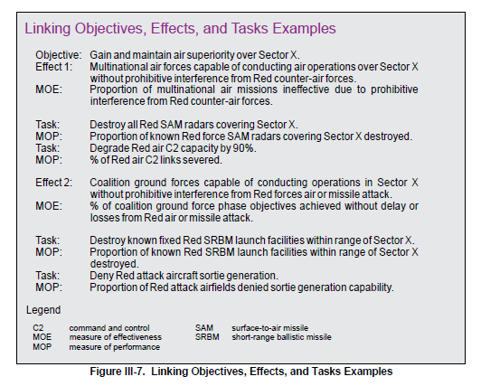

JP 5.0 Operational planning

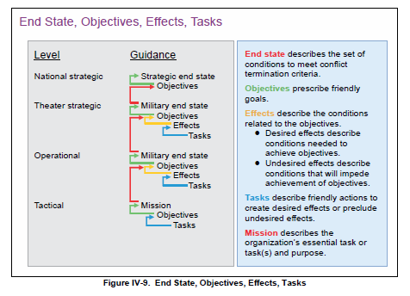

Source: JP 5.0 Joint Planning

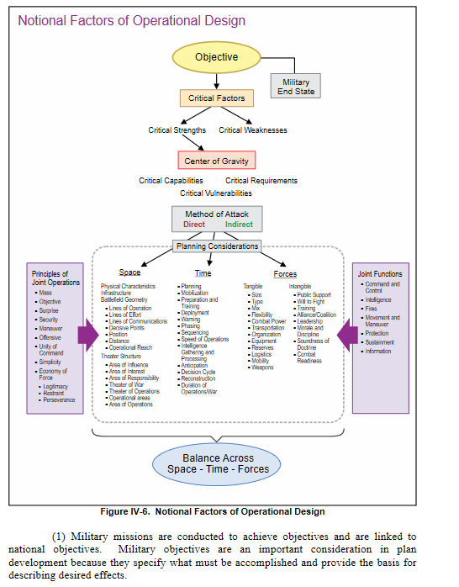

John Warden CASE I-IV

Here is a section from Warden III, John A.. The Air Campaign: Planning For Combat (pp. 37-39). Tannenberg Publishing. Kindle Edition.

In the first case, Case I, both sides have the capability and will to strike at each other's bases. This case was the situation in the Pacific in the first part of World War II, when both Japanese and Allied forces could and did strike bases behind each other's lines.

The second case, Case II, occurs when one side is able to strike its enemy anyplace, while the enemy can do little more than reach the front. Case II is typified by the Grand Alliance of the United States and Great Britain-against Germany after 1943. From that point on, the Allied air forces were able to attack Germany without fear of militarily significant ripostes by the Germans. Case II also suggests that war involves phases. A war that starts out with a particular air situation may not end with the same situation prevailing. Phasing will be discussed in subsequent chapters.

Case III is the reverse of Case II and is a dangerous situation. Here, one side is vulnerable to attack but is unable to reach the enemy. It is the situation in which Britain found herself during the Battle of Britain. She did not feel she had the capability to strike the Luftwaffe fields in France; thus, for practical purposes, German bases were safe during the two months of the battle.{24}

The fourth case, Case IV, describes the situation in which neither side can operate against the rear areas and air bases of the enemy, and in which air action therefore is confined to the front.

Case IV is best illustrated by the Korean War, where the United States imposed on itself political constraints which prohibited operations against Chinese fields and infrastructure north of the Yalu River. The Communists, on the other hand, were unable to attack American fields effectively.

The last case, Case V, could come about through mutually agreed political constraints or because neither side had any air power. For example, proxies of two great powers might meet in a place where neither power chose to provide combat aircraft. Clearly, either side could change the rules; thus, it would be useful for participants to anticipate that possibility. Similarly, a war between two poor countries might not involve any significant air activity. Again, though, commanders on both sides would be prudent to think about what would happen if air forces did arrive.

JFACC ROLE DESCRIPTION

Joint Force Air Component Commander (JFACC) is the commander of the Joint Air Forces in the operation (Both Navy and Air Force, so for us in the 132nd, all air forces)

The JFACC role is about giving the direction and guidance for air operations. JFACC will publish its guidance before each event in the Air Operations Directive (AOD), and this direction and guidance will be used by everyone involved, especially AWACS controllers and mission commanders/flight leads for planning packages or flights.

JFACC TASKS

Develop a Air Operation Plan - (see example in Appendix C, “Joint Air Operations Plan Template”).

Recommend air apportionment priorities to the JFC that should be devoted to the various air operations for a given period of time, after considering objective, priority, or other criteria and consulting with other component commanders.

Allocate and task the joint air capabilities and forces made available by the Service components based on the JFC’s air apportionment decision.

Provide the JFACC’s guidance in the air operations directive (AOD) for the use of joint air capabilities for a specified period that is used throughout the planning stages of the joint air tasking cycle and the execution of the ATO. The AOD may include the JFC’s apportionment decision, the JFACC’s intent, objectives, weight of effort, and other detailed planning guidance that includes priority of joint air support to JFC and other component operations (see Appendix D, “Air Operations Directive Template”).

Provide oversight and guidance during execution of joint air operations.

Assess the results of joint air operations and forward assessments to the JFC to support the overall assessment effort.

Create/Update Airspace Control Plan (ACP )

Air Campaign Planning

The Air Campaign Plan will contain three main components. First, it will define the JFACC’s concept of operations (CONOPS. Second, it will identify specific military objectives and target systems in a Master Attack Plan (MAP). Finally, it will allocate specific tasks to specific units in a detailed Air Tasking Order.

An Air Campaign will normally consist of two phases:

• gaining control of the air, and

• other air operations (for example, strategic attack, interdiction. close air support. maritime strike)

The Air Campaign Plan should describe centres of gravity, the phasing of operations,

and the resources required.

Air Campaign Planning Considerations

There are several critical considerations which must guide the development of an air campaign plan:

The nature of the enemy must be understood. The JFACC must know the enemy’s strengths and weaknesses, what resources he has, and how he is likely to respond to a range of contingencies.

Make an assessment of the enemy's capabilities relative to our own. From that, it follows that the JFACC must know how best to use VIS intelligence resources.

• Initiative is vital. The side which takes the offensive in the war in the air has a distinct advantage. If the opposing forces are fairly equal, the side that moves first will gain the tactical and operational initiative.

Although the JFACC may have to assume the defensive initially, he should be ready to go onto the attack as soon as conditions are favourable. Once he goes onto the offensive, targeting priorities assume vital importance.

Centres of Gravity (COGs)

• Centres of Gravity are the key to targeting. A centre of gravity is that point where the enemy is most vulnerable; which if successfully attacked is most likely to bring about his defeat. If there are numerous centres of gravity, they may all have to be successfully attacked for the objective to be achieved. Correctly identifying centres of gravity in relation either to the overall strategic objective or to the immediate tactical objective (depending on the state of the conflict), and then determining how best to attack them is crucial to the air campaign plan.

Key features of a centre of gravity are its importance to the enemy’s:

• ability to wage war,

• motivation and willingness to wage war, and

• political body, population, and armed forces.

Additionally, the enemy’s consciousness of those factors will have a bearing on the attractiveness of a target.

Centre of gravity analysis can save an enormous amount of effort. For example, it may not be necessary to find and destroy an enemy’s 2000 tanks if the 50 fuel and ammunition distribution points which support them can be neutralised. Similarly, it may not be necessary to find and destroy the distribution system if the enemy nation can be immobilised by finding and destroying 10 key electrical generation systems. Finally, it may not be necessary to find and attack the electrical system if the leadership elite can be killed, captured, or made ineffectual.

Targeting

Joint Planning and Targeting List (JPTL) - create a master Targeting list and prioritize accordingly.

Create a Notional Targeting List - used to modify master target list.

Create Targeting lists for each Day as required including - HPTs, HVTs, TSTs.

Create Master Attack Plan

Translating the Air Campaign Plan into usable instructions for the 132nd is done through the Master Attack Plan and the Air Tasking Order.

The Master Attack Plan (MAP) identifies specific military objectives and target systems.

It is the end result of centre of gravity analysis, target selection, aim point selection and current intelligence. For example, the Master Attack Plan for the first stages of Desert Storm reflected the following objectives:

• Destroy/ neutralise air defence command and control.

• Destroy nuclear, biological and chemical storage and production capability.

• Make ineffective the national and military command, control and communications infrastructure.

• Destroy key electrical grids and oil storage facilities.

• Deny military resupply capability.

• Eliminate the long-term offensive capability.

• Make the Republican Guards ineffective.

The JFACC, General Horner, had sufficient air power to execute that plan concurrently (‘in parallel’). For more limited assets such as what we are able to bring forward in the 132nd, sequencing will be necessary, and the JFACC’s determination of that sequence will be vital.

Note that the MAP represents a dynamic process and may change with the course of

the battle.

Source: AIR POWER STUDIES CENTRE PAPER NO. 18 Alan Stephens and Gary Waters October 1993

COG

Reference:

https://www.doctrine.af.mil/Portals/61/documents/AFDP_3-0/3-0-D30-Appendix-1-COG-Analysis.pdf



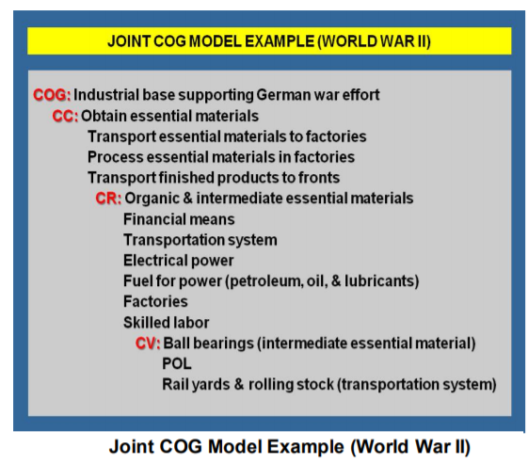

The Air Tasking Order

The final stage in the planning process described in the preceding pages, and which has progressively ‘flowed down’ from strategic to operational to tactical considerations, is represented by the Air Tasking Order (ATO). The ATO is issued daily (campaign day - not realtime!) and allocates specific tasks to specific units. It thus provides aircrews with the details they need to execute the MAP.

Mission Type Orders

In many situations, the JFACC issues mission type orders (MTO) to assigned and attached air units. MTOs state the objectives to be accomplished but leave the detailed mission planning to the tasked units. This enables subordinate echelons to exploit fleeting opportunities better.

Mission type orders can help the JFACC reduce “micro-management” when developing and transmitting an ATO. JFACCs pass along required planning information to units via SPINS and the ACO and normally include their commander’s intent as part of the ATO. Package Commanders and flight leaders determine the tactics employed to accomplish the missions at the unit level, using decentralized orders. This represents the “decentralized execution” vital to aerospace flexibility.

Source: Command and Control of Joint Air Operations through Mission Command - Carpenter. (56).

Determine course of actions (COA) and assess most likely COA for the enemy.

Example:

OPFOR are expected to have a manned Defensive Counter Air (DCA) posture at the commencement of each VUL. This DCA posture could include up to 26 fighter aircraft.

OPFOR are expected to have up to 50 aircraft on varying states of alert at each airfield. OPFOR have been known to operate at ALERT States to include: 3min / 30min / 60 min alert.

OPFOR have shown some intent to attack Blue land infrastructure targets. They are most likely to use a dedicated Strike package to achieve this aim. OPFOR have shown a desire / intent to destroy Blue air heavy wing assets should the opportunity present itself.

Source: VIRTUAL PITCH BLACK 2018 AIR BATTLE PLAN

Air Tasking Cycle Stages / battle rythm

The air tasking cycle consists of six stages. Unlike the targeting cycle, the air tasking cycle is time-dependent, built around finite time periods to plan, prepare for, and conduct joint air operations.

Stage 1: Objectives, Effects, and Guidance.

Stage 2: Target Development.

Stage 3: Weaponeering and Allocation.

Stage 4: ATO Production and Dissemination.

Stage 5: Execution Planning and Force Execution.

Stage 6: Assessment. Assessment is performed

by all levels of the joint force.

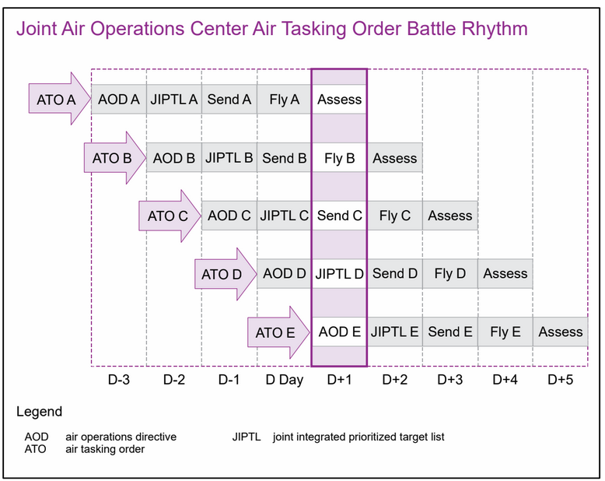

Source: Joint Pub 3-30 Joint Air Power

Overall concept for Air Operations planning for campaigns in the 132nd

(Need to be adjusted)

Source: Air Force Doctrine Document 2-1, 1999

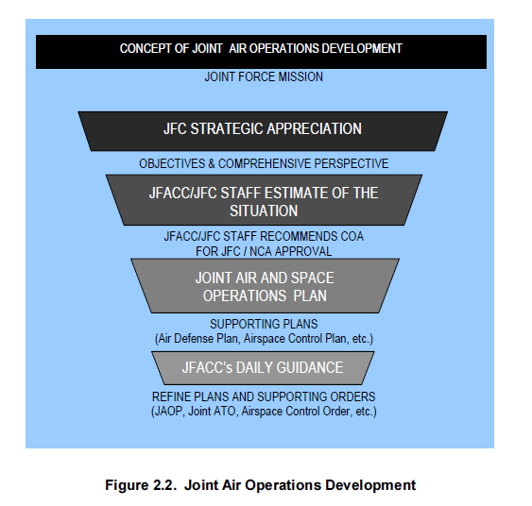

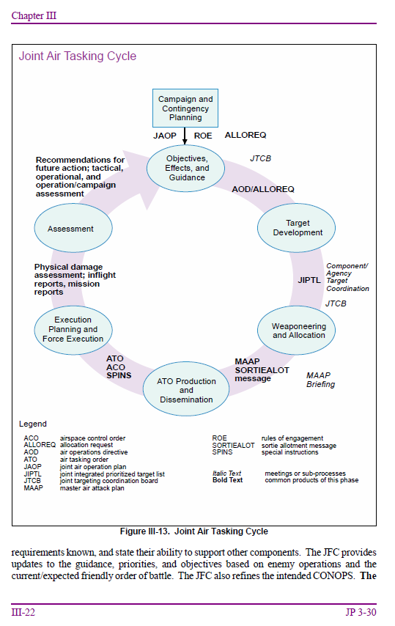

Example of Mission Type orders (JESTER: Ok so this is basically just the AOD)...

Commanding Officer, 308th Bomb Wing will:(1) Carry out necessary reccos as required.(2) Provide fighter cover for defense of BIAK and NOEMFOOR. (3) Provide fighter cover for friendly naval shipping as required.(4) Attack targets in GREELVINK BAY and VOGELKOP areas per plan of Commanding Officer, 308th Bomb Wing.(5) Utilize maximum B-24s for strikes on PERELIRU ISLAND. Commanding Officer, 309th Bomb Wing will: (1) Attack personnel and supplies in WEWAK-BUT-BORAM area per plan of Commanding Officer.

Commanding Officer, 310th Bomb Wing will:

(1) Provide local cover of HOLLANDIA and WAKDE.

(2) Support friendly ground forces as required per plan of Commanding Officer.

(3) Provide fighter cover for troop carriers to OWI ISLAND as required.

(4) Conduct night missions to VOGELKOP area using available night fighters.

(5) Release one group B-25’s to control of the 308th Bomb Wing.41 This field order instructed the Fifth Bomber Command to provide

squadrons to the three composite wing (air task force) commanders and

instructed the 54th Troop Carrier Wing to place six squadrons of C-47s under

Source: MISSION-TYPE ORDERS IN JOINT AIR OPERATIONS The Empowerment of Air Leadership - FISCHER, MAJOR, USAF (1995)